Hill Lane Surgery
Newsletter
February 2020

Hello and welcome to our newsletter.

Have you heard about the ‘Coronavirus’?
Well here is some information for you regarding
‘WUHAN NOVEL CORONAVIRUS INFECTION’
All travellers who develop relevant symptoms ( for example respiratory symptoms, shortness of breath, cough, fever) however mild, within 14 days of returning or transitioning from mainland China, Thailand, Japan, Republic of Korea, Hong Kong, Taiwan, Singapore, Malaysia or Macau should not attend the practice, but should remain at home and immediately call NHS 111 for advice.
Please don’t panic.

Also Dr Enelka is no longer with the practice. Although she was here for a short period of time she will be extremely missed, good luck to her for the future. We would like to welcome our new Doctor, Dr Philippa Keech.

Kind Regards
Laura
Practice Administrator
Hill Lane Surgery

'Try the new NHS App’
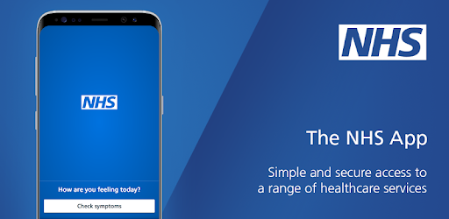
You can now use the new NHS App, a simple and secure way to access a range of NHS services on your smartphone or tablet.
You can use the NHS App to check your symptoms and get instant advice, book appointments, order repeat prescriptions, view your GP medical record and more.
If you already use our Hill Lane website, you can continue to use it. You can use the NHS App as well.
For more information go to www.nhs.uk/nhsapp
(You might also need to review existing website content to make sure it covers the different options patients have to connect with online services.)

https://www.jostrust.org.uk/about-us?gclid=CjwKCAiAhfzSBRBTEiwAN-ysWIVlPzyexe1oe2o5AZ3ZG0S500W5xKV9ymS5hBKyq90IyKuUZhqHARoCWPkQAvD_BwE
Please call the surgery to book an appointment if your smear is due. Please click on the link above for more information, and answers to lots of questions about cervical screening.
"A smear test lasts 5 minutes. The Impact of cervical cancer lasts a lifetime"
Attend your smear test.

Reduce your risk.

